Smart Classroom

In this project you will make a virtual classroom that can react to what you say to it.

You’ll be able to control the virtual devices in the classroom by saying what you want.

You will teach the computer to recognise commands for different devices by giving it examples of each.

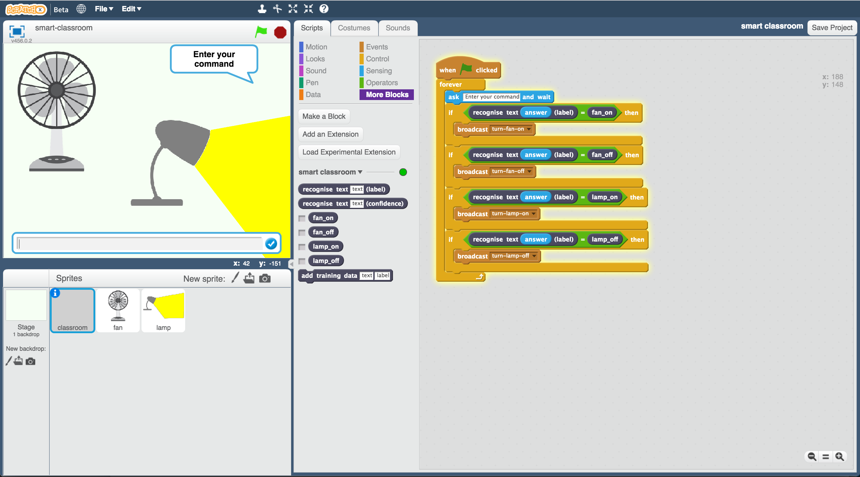

Creative Commons LicenceThis project worksheet is licensed under a Creative Commons Attribution Non-Commercial Share-Alike License

http://creativecommons.org/licenses/by-nc-sa/4.0/

1. Go to <https://machinelearningforkids.co.uk/> in a web browser
2. Click on “**Get started**”
3. Click on “**Try it now**”
4. Click the **“+ Add a new project**” button.
5. Name your project “smart classroom” and set it to learn how to recognise “**text**”. Click **Create**  
   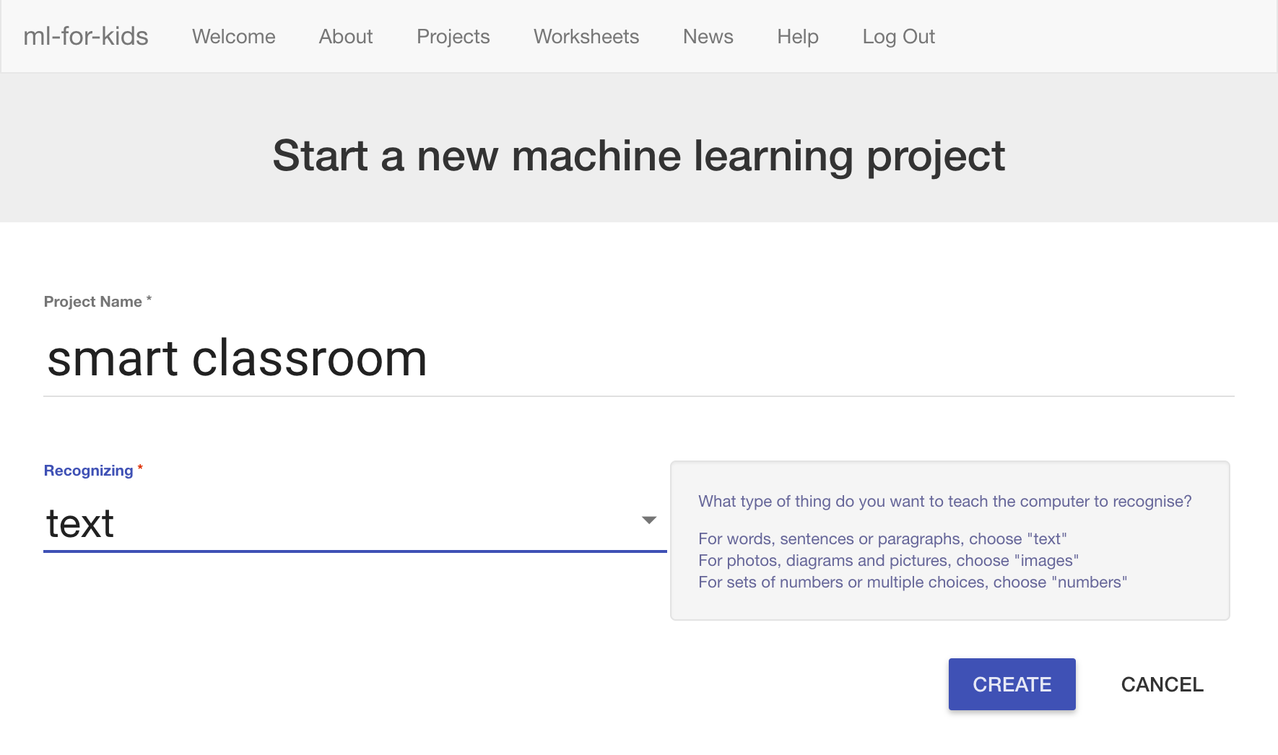
6. You should see “**smart classroom**” in your projects list. Click it.  
   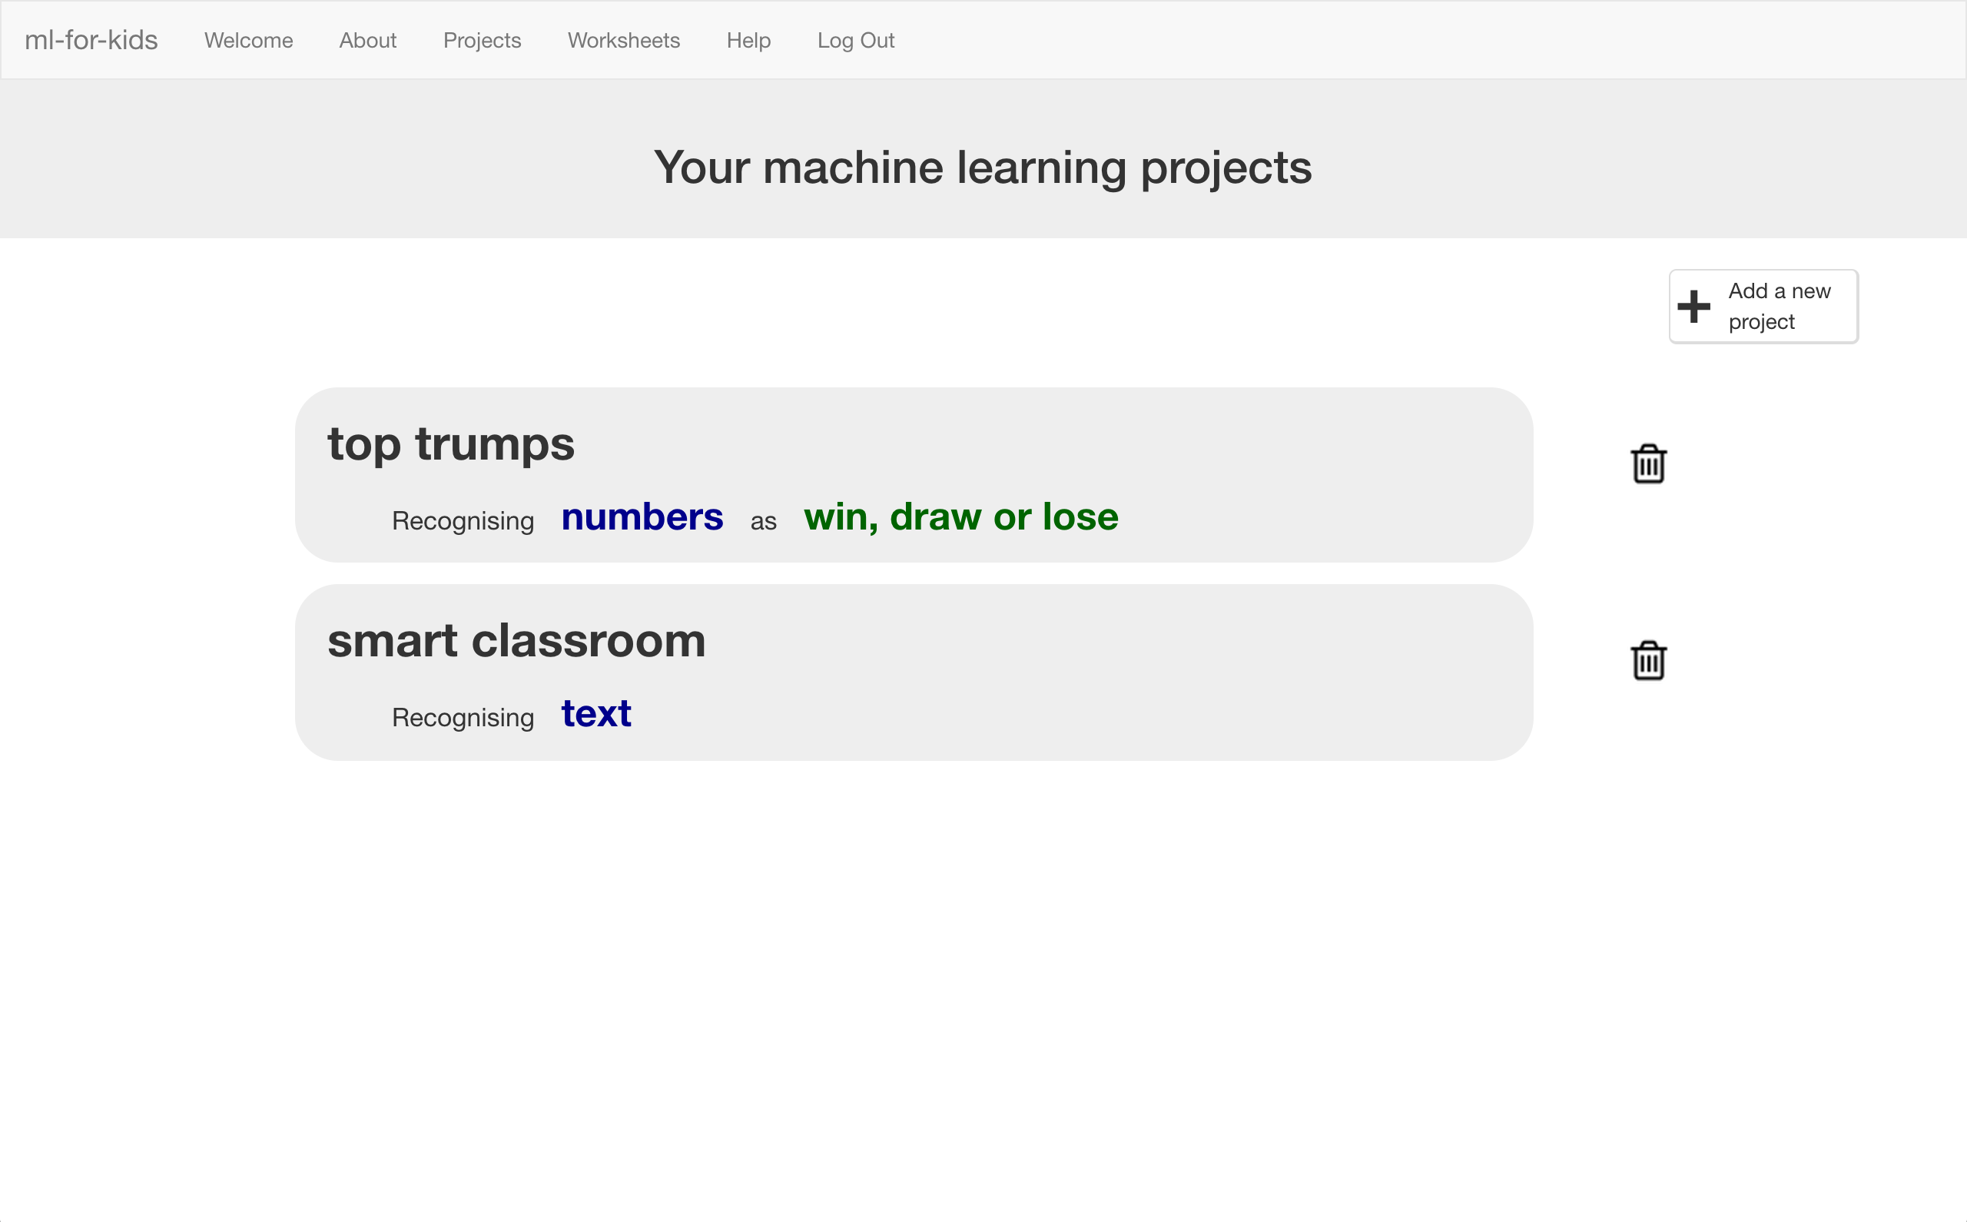
7. We need to collect some examples to train the computer.   
   *Click the* ***Train*** *button.*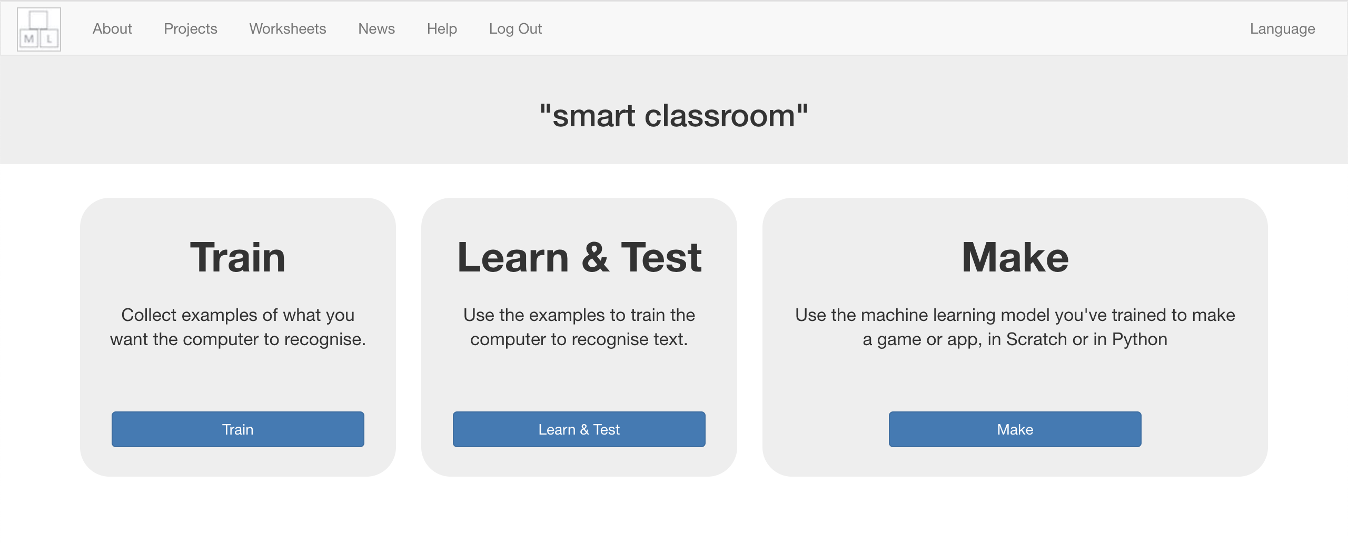
8. Click on **“+ Add new label**”   
   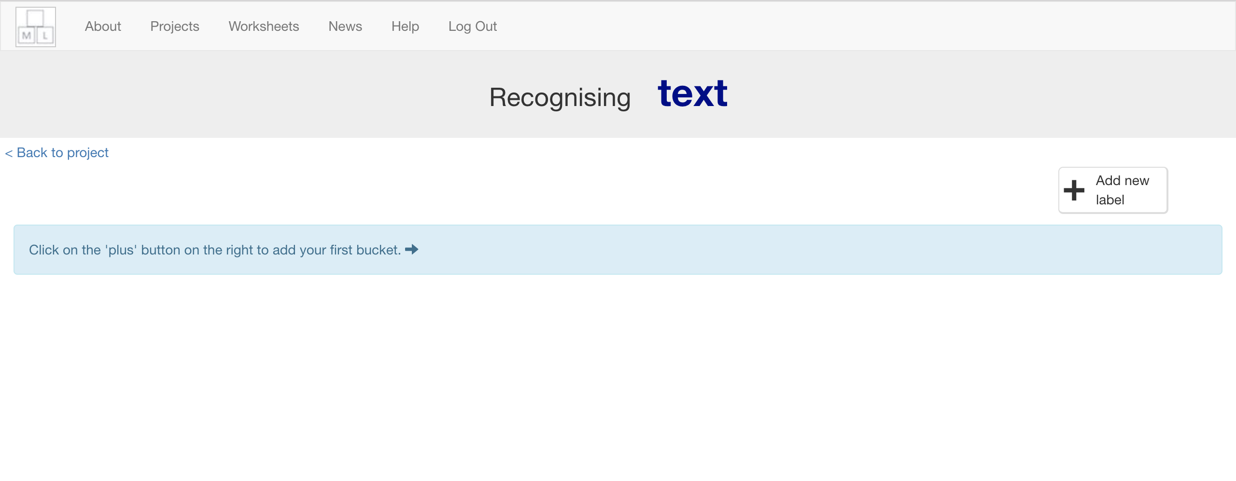
9. Type in “fan on” and click “**ADD**”  
   *This will create the first bucket for your training examples.*   
   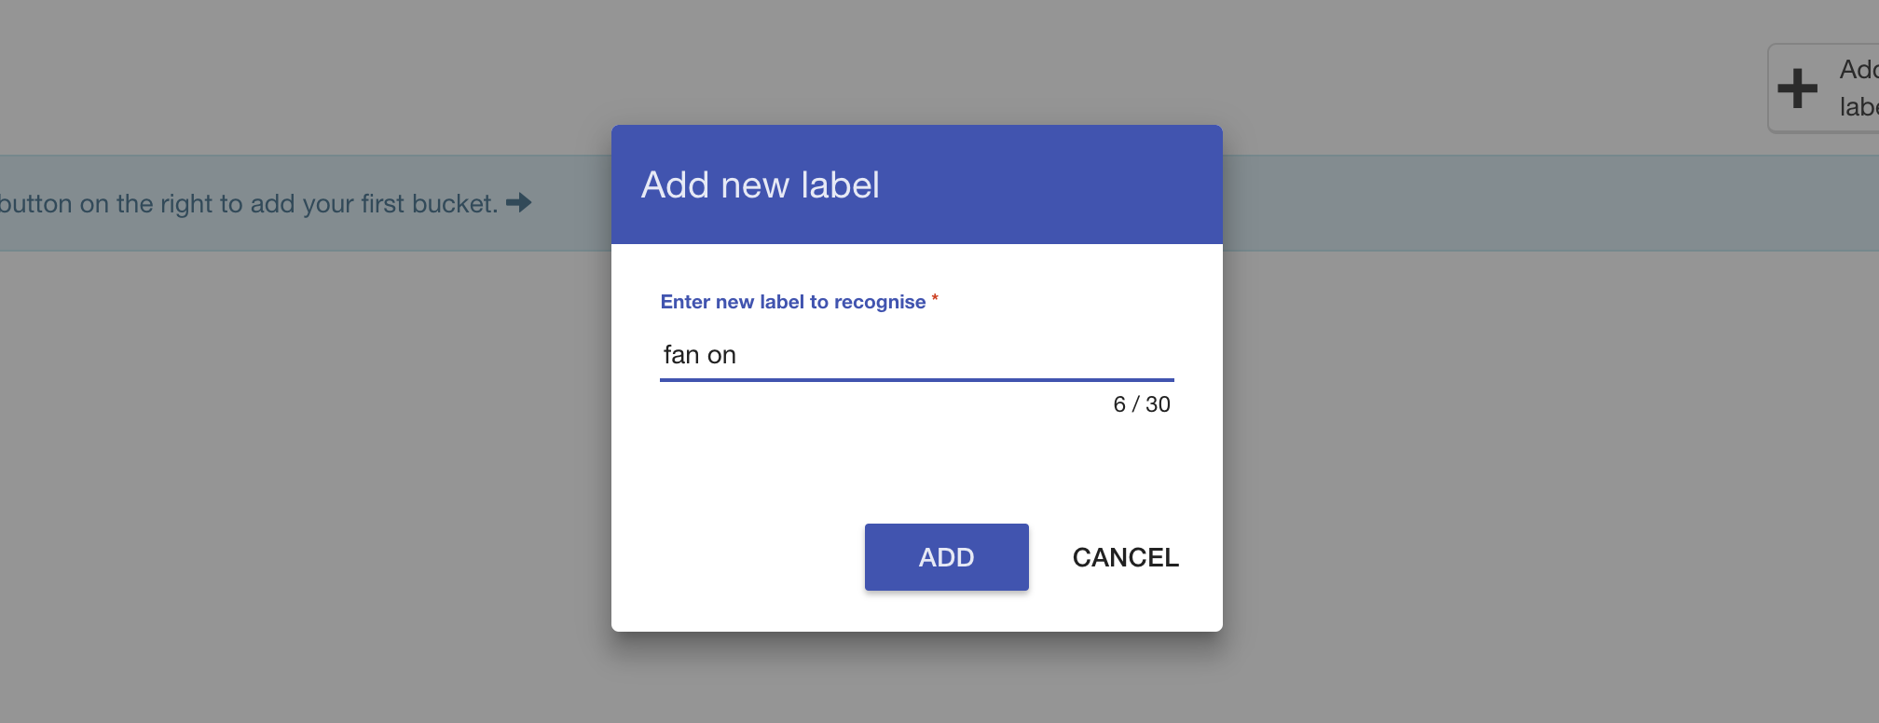
10. Click on **“+ Add new label**” again
11. Create a second bucket called “fan off”  
    Do that again. Create a third bucket called “lamp on”.  
    Do that again. Create a fourth bucket called “lamp off”.  
    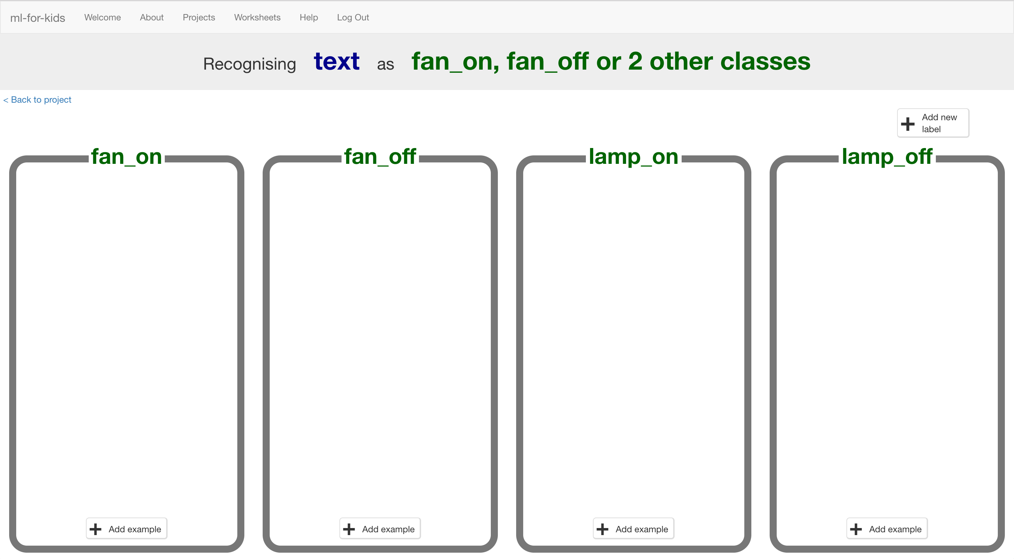
12. Click on the “**Add example**” button in the “fan on” bucket

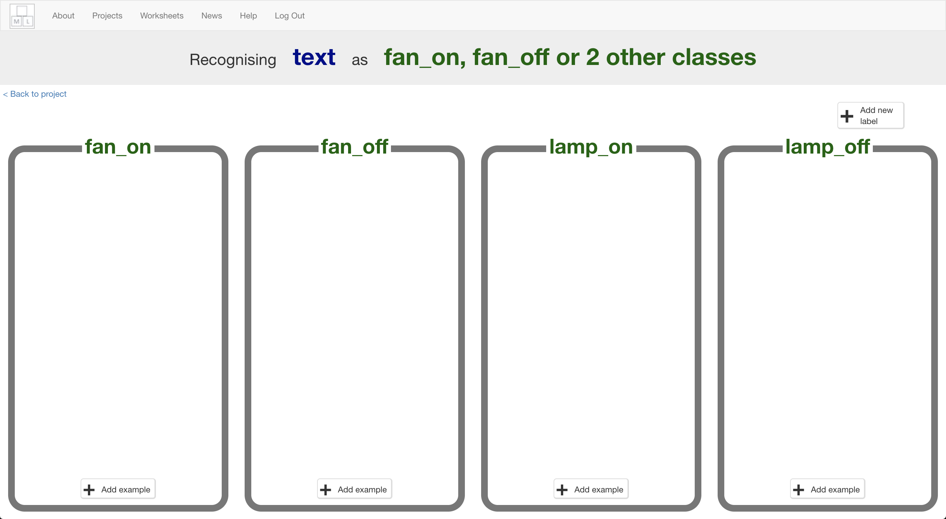

1. Type in a way to ask for the fan to be turned on, then click “**ADD**”  
   *For example, you could type “Please can you switch on the fan”.*
2. Click on the “**Add example**” button in the “fan off” bucket, and type in a way to ask for the fan to be switched off.  
   *For example, you could type “I want the fan off now”*
3. Do the same for the “lamp on” and “lamp off” buckets.
4. Repeat steps 12-15 until you’ve got at least **six** examples of each.  
   *Be imaginative! Think of lots of different ways to ask each command.   
   For “fan on” you could complain that you’re too hot.   
   For “fan off” you could complain that it’s too breezy.   
   For “lamp on” you could complain that it’s too dark or that you can’t see.   
   For “lamp off” you could complain that it’s too bright.*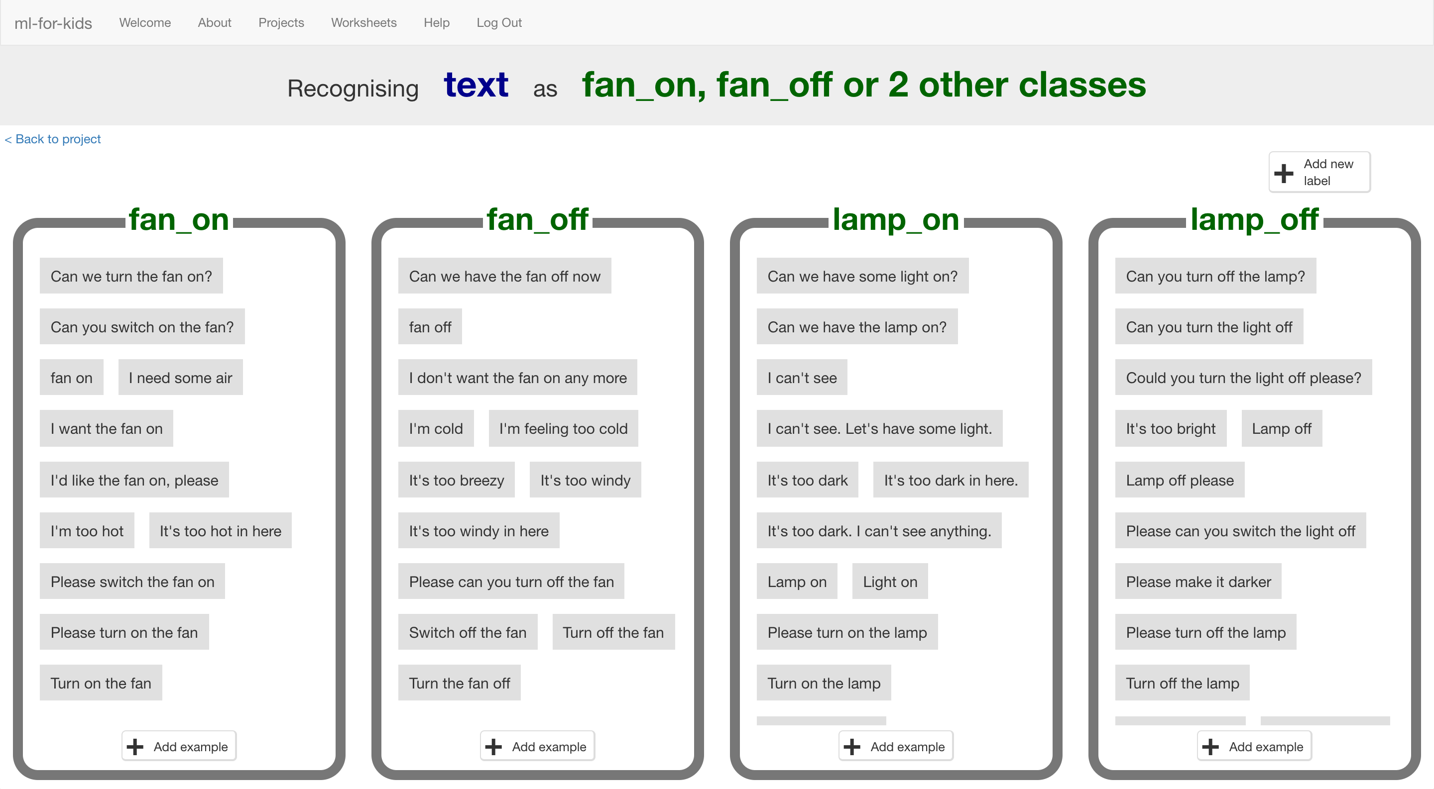
5. Click the **“< Back to project**” link, then click “**Learn & Test**”.
6. Click the “**Train new machine learning model**” button. 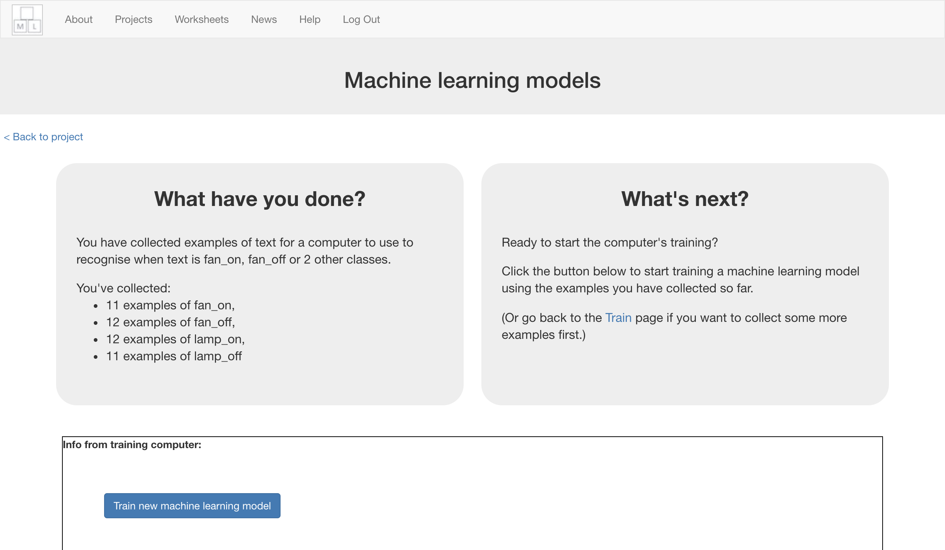
7. Wait for the training to complete. This might take a minute or two.  
   *Try the multi-choice quiz at the bottom of the page while you wait.*
8. Once the training has completed, a Test box will appear.   
   Try testing your machine learning model to see what it has learned.   
   Type in a command, and press enter.  *Test it with examples that you haven’t shown the computer before.   
   If you’re not happy with how the computer recognises the messages, go back to step 12, and add more examples.   
   Make sure you repeat step 18 to train with the new examples!*

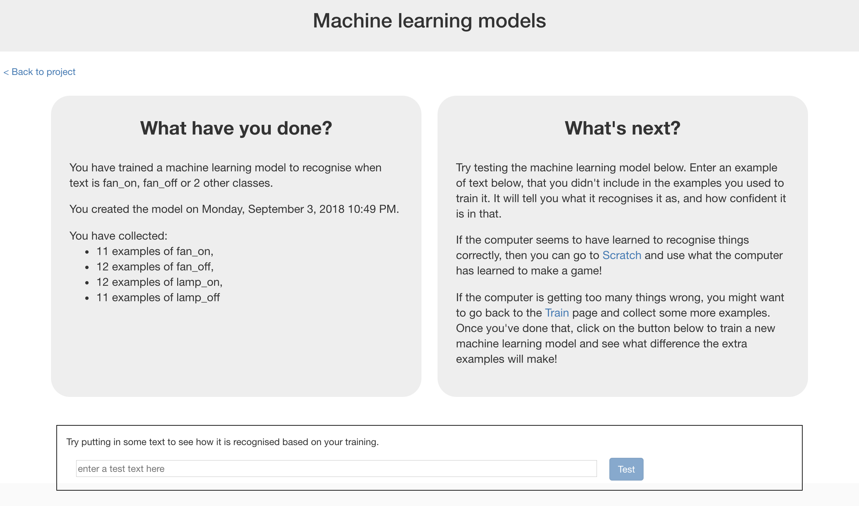

1. Click on the **“< Back to project**” link, then the “**Make**” button.   
   
2. Click “**Scratch**”  
   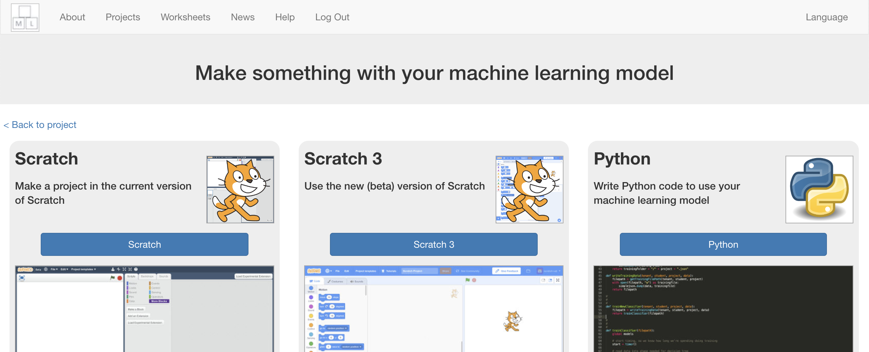
3. Click “**Open in Scratch**” to launch the Scratch editor  
   *This page has instructions on how to use your project in Scratch.*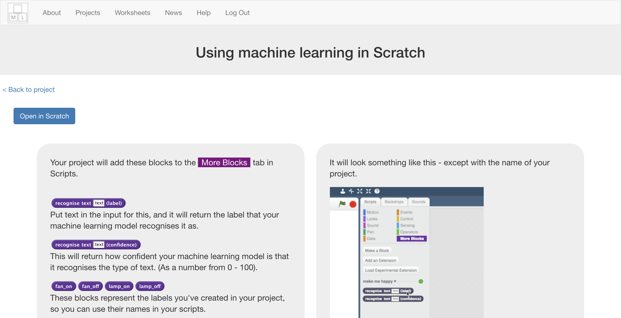
4. You should see new blocks in the “**More blocks**” section from your   
   “smart classroom” project.  
   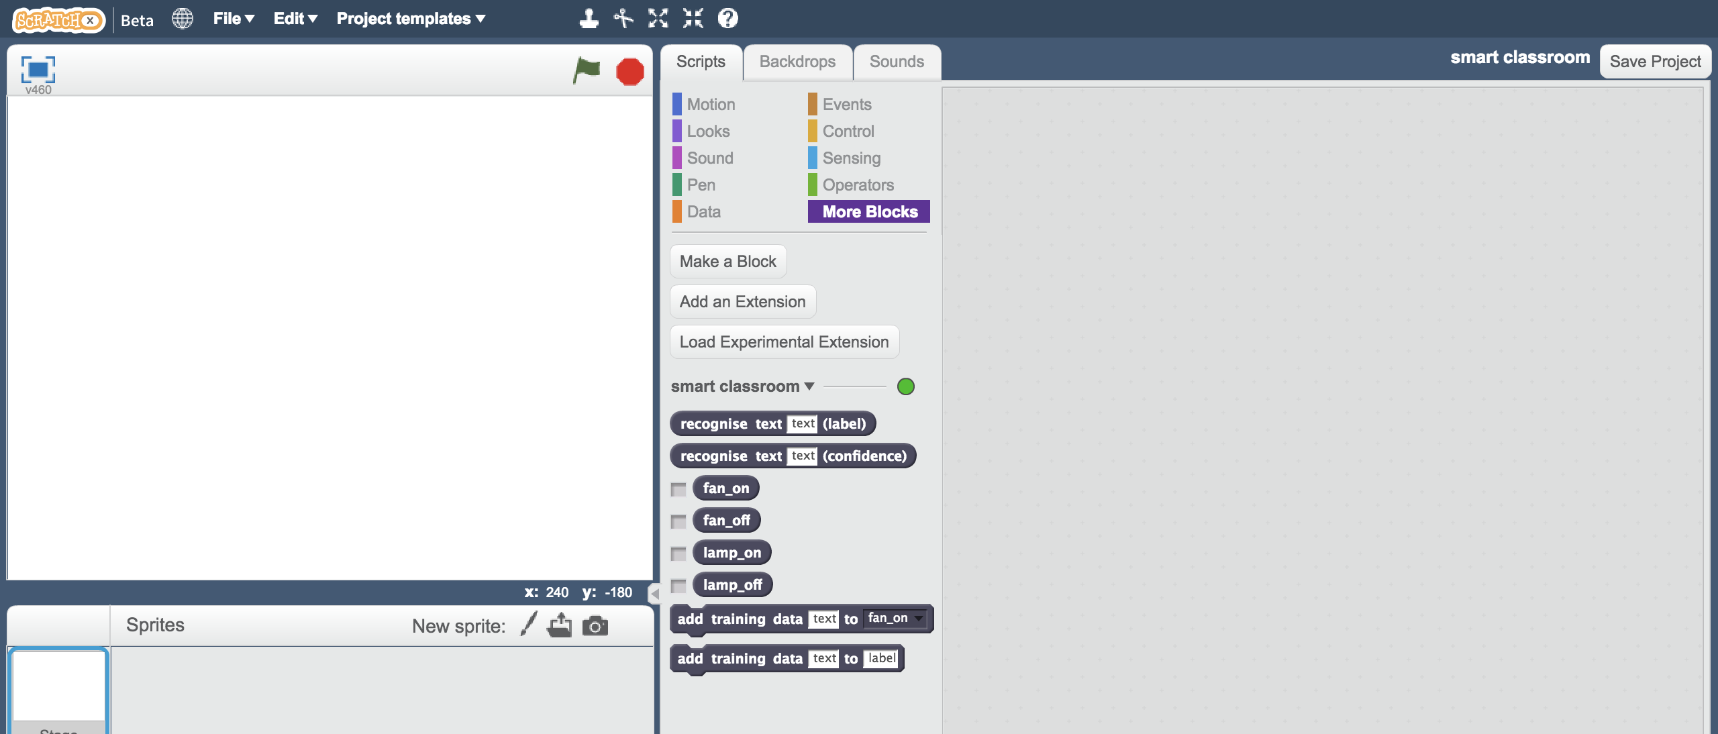
5. Load the **Smart Classroom (short)** template   
   *Click on “Project templates” -> “Smart Classroom (short)”  
   Click “OK” when it asks to replace the current project*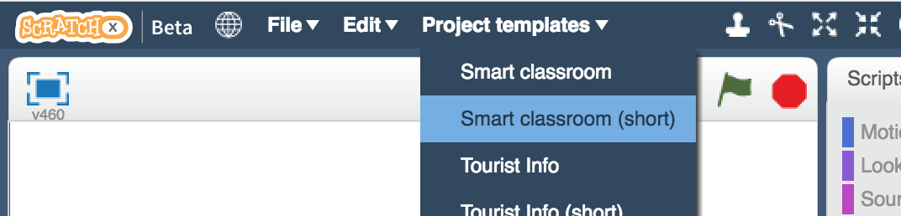
6. Click on the “**Scripts**” tab, and **change** the existing script, to use your machine learning model **instead** of the rules that are already there.  
    *The “recognise text … (label)” block is a new block added by your project.   
   If you give it text, it will return the label for one of the four commands based on the training you’ve given to the computer.*  
   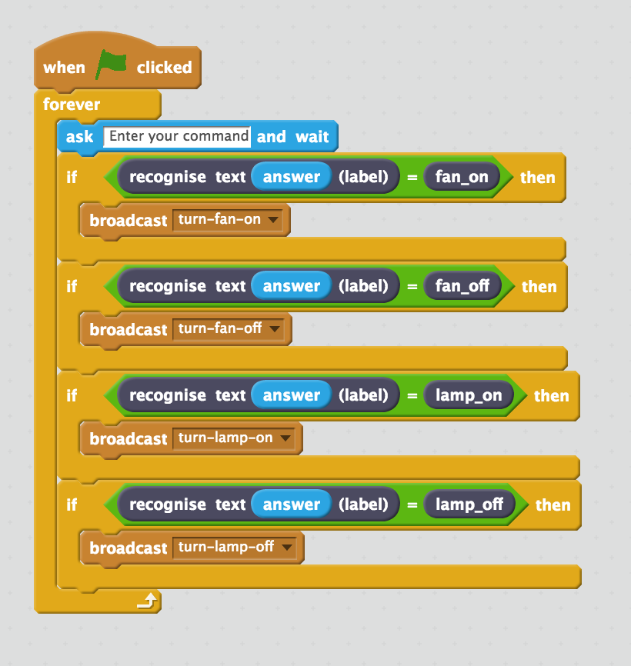
7. Click the **green flag** to test   
   *Type a command and press enter. The fan or lamp should react.   
   Make sure you test that this works* ***even for messages that you didn’t include in your training****.*

**What have you done?**

You’ve trained a smart assistant – like a simple version of assistants you can get on modern smartphones (like Apple’s Siri or Google’s Assistant) or virtual assistant devices (like Amazon’s Alexa or Google’s Home).

Training the computer to be able to recognise instructions for itself should be much quicker than trying to make a list of every possible command.

The more examples you give it, the better it should get at recognising instructions correctly.

**Ideas and Extensions**

Now that you’ve finished, why not give one of these ideas a try?

**Try another device**

Instead of just a fan and a lamp, can you add another device to your smart classroom?

**Use the confidence score**

The other new Scratch block from your project gives the score for how sure your machine learning model is that it has recognised the message.

If you give it a command like “Please make me a cheese sandwich”, the confidence score should be very low.

How can you use this to improve your script for commands that the computer can’t recognise?

**Do it for real!**

Have a look at the smart assistants that developers have made for Amazon’s Alexa : <http://amzn.to/2sxy1hw>

Developers made these in the same way that you did this project – creating labels for the commands they wanted it to recognise, and then collecting examples of how those commands might be phrased to train the Alexa to be able to understand them.

Find an Alexa Skill that you think sounds good. Look at the commands it can understand – can you think how you could’ve trained it?